IHCI Project Proposal

# Rules

* Submit a Google Doc, NOT a PDF or a Google slide.
* Use the default fonts, line spacing, and font size unless specifically required in the assignment.
* After submission, the Google Doc will get automatically locked, so you won't be able to make any changes.
* Standard plagiarism rules apply
* Your submission will not be considered for grading and feedback if you do not follow these guidelines.

**Names of Group Members: Riya Sachdeva**

**Rohak Kansal**

**Rohan Beriwal**

**Rohan Devgon**

**Rohan Indora**

**Project Group Number: 3**

**HCI Group No.: 6**

## Problem Statement - Pet Rescue App

Despite the presence and active efforts of many dedicated NGOs, there is no shortage of abandoned, injured, aggressive, or non-neutered stray animals on the streets. Our aim is to provide a **common platform** to volunteers, animal rescuers, potential foster parents, housing societies, veterinarians, NGOs, and other stakeholders for coordinating rescue operations, providing shelter and medical facilities to the animals, adopting them, etc.

## Background of the Problem and Motivation

* India’s overall (all pets wanted, cared for, and welcome) score on the State of Pet Homelessness Index is 2.4 (out of 10). It is very low compared to USA’s 6.4, UK’s 7, and Germany’s 8.6. There are nearly 8 crore homeless animals in the country (including 6.2 crore street dogs and 91 lakh street cats) and 88 lakh street animals in shelter homes.
* Due to lack of behavioural awareness about stray pets people in India prefer buying luxury breeds of dogs and cats instead of adopting from shelters. Relinquishment levels are also high in India (50%) as compared to the global level (28%).
* Despite the high percentage of diseased dogs (rabies, TVT, and fleas/ticks) in India, prompt veterinary care is unavailable, especially for strays.
* Data by Nagpur Municipal Corporation (NMC) has revealed that from 2011-12 till July 2019, around 11,915 stray animals including dogs, cats, cattle and goats were injured in road accidents in different parts of the city. The number of accidents involving stray animals has increased by almost 23% in the last six years, many of which go unreported due to people’s ignorance and lack of knowledge regarding whom to contact.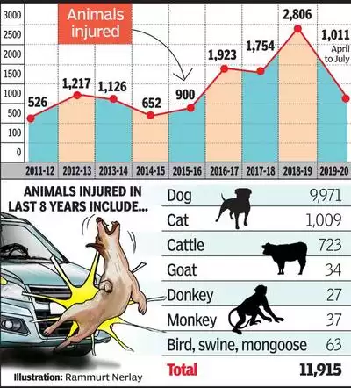
* A research by the National Center for Biotechnology Information shows that high early life mortality in free-ranging dogs is largely influenced by humans (63%). “Only 32% of the total mortality was by natural causes and for 5% of total mortality there were no reliable records. The remaining 63% of the total mortality was influenced directly (accidents/ poisoning/ beatings) or indirectly (taken away from the population) by humans.”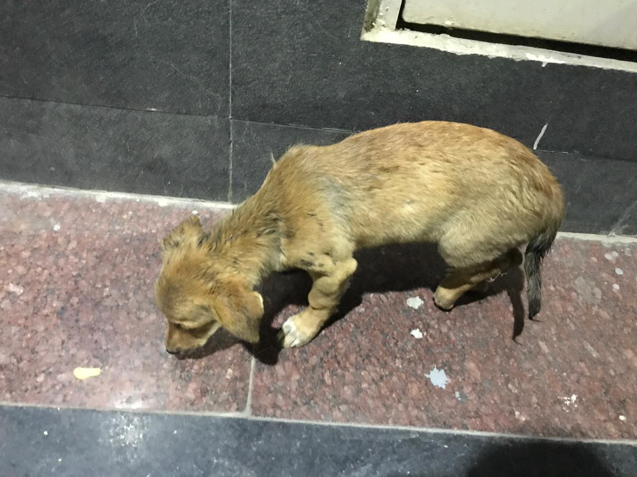
* A few weeks ago, a student of IIITD posted the picture of an injured dog found near Govindpuri Metro Station on the WhatsApp group, asking people for phone numbers of NGOs that could rescue the dog. As it was late in the evening, most NGOs he contacted were unavailable, and it was a long time before the dog was taken to a shelter. The unnecessary delay and hassle could’ve been avoided had there been an app that connected people to the local NGOs. This is the event that drove us to choose this project.

## Scope

### Components

* There will be an option on the home page to upload the picture, location and other details of an abandoned stray animal. There will also be an emergency contact option for people in need of immediate assistance.
* People will be able to register themselves as volunteers and dedicate a few hours weekly to rescue operations, treatment of animals, etc.
* NGOs, vets and people willing to foster/adopt animals will be connected on one integrated interface and be able to communicate with each other.
* People will be able to report missing animals and seek help in finding them.

### Salient Features

* We will create a system of badges to provide recognition to companies that fund our cause. The badges will set a standard that companies can boast on their website and products.
* Volunteers will be able to earn discount coupons for working a certain number of hours. For that, we can partner up with chains like Starbucks, Chaayos, Domino’s etc.
* We will collaborate with universities to introduce an option for students to earn Community Work credits by volunteering through the app.
* Recognition (badges) earned by people/companies contributing to the cause will be accepted on resumes, LinkedIn and other social media.
* We will regularly organise workshops in various localities to reduce the stigma associated with stray animals and to drive a culture of ownership, and also to increase the user base.
* We will conduct frequent vaccination and sterlisation campaigns, which will reduce the number of strays on the streets in the long run.

### Limitations

* We’ll set up the app for a city initially, but we’ll have to continuously expand the active user base in order for the app to remain relevant.
* If there aren’t enough people in a locality willing to adopt healthy stray animals, NGOs won’t be able to help other wounded ones due to lack of funds and the app will become ineffective.

## Contributions

Ideation - Rohak Kansal

Data Gathering/Research - Rohan Indora, Rohan Beriwal, Rohan Devgon

Framing, Compilation, and Editing - Riya Sachdeva

## Sources

<https://timesofindia.indiatimes.com/city/nagpur/over-1k-stray-animals-injured-in-road-accidents-in-4-months/articleshow/70965326.cms>

<https://www.indiatoday.in/india/story/how-many-stray-cats-dogs-loiter-unsheltered-in-india-1881222-2021-11-26>

<https://www.ncbi.nlm.nih.gov/pmc/articles/PMC4726281/>

<https://economictimes.indiatimes.com/news/india/india-has-80-million-homeless-dogs-cats-has-highest-levels-of-abandonment-mars-petcare-report/articleshow/87916334.cms?from=mdr>

[The State of Pet Homelessness Index (endpethomelessness.com)](https://endpethomelessness.com/the-index/)

https://english.mathrubhumi.com/amp/news/kerala/change-in-behavioural-pattern-of-stray-dogs-won-t-be-easy-to-change-1.7854622

https://www.firstpost.com/explainers/explained-gurugram-bans-11-dog-breeds-what-are-they-how-dangerous-are-they-11646291.html/amp

https://www.indiatoday.in/amp/cities/story/gurugram-dog-breeds-banned-dangerous-aggressive-dogo-argentino-pit-bull-2298315-2022-11-17